Rohan Patel

Daniel Nazarian

Kyle Romm

Jamie Maignan

Group 9

Home Quiz 3

Home Quiz 3 Report

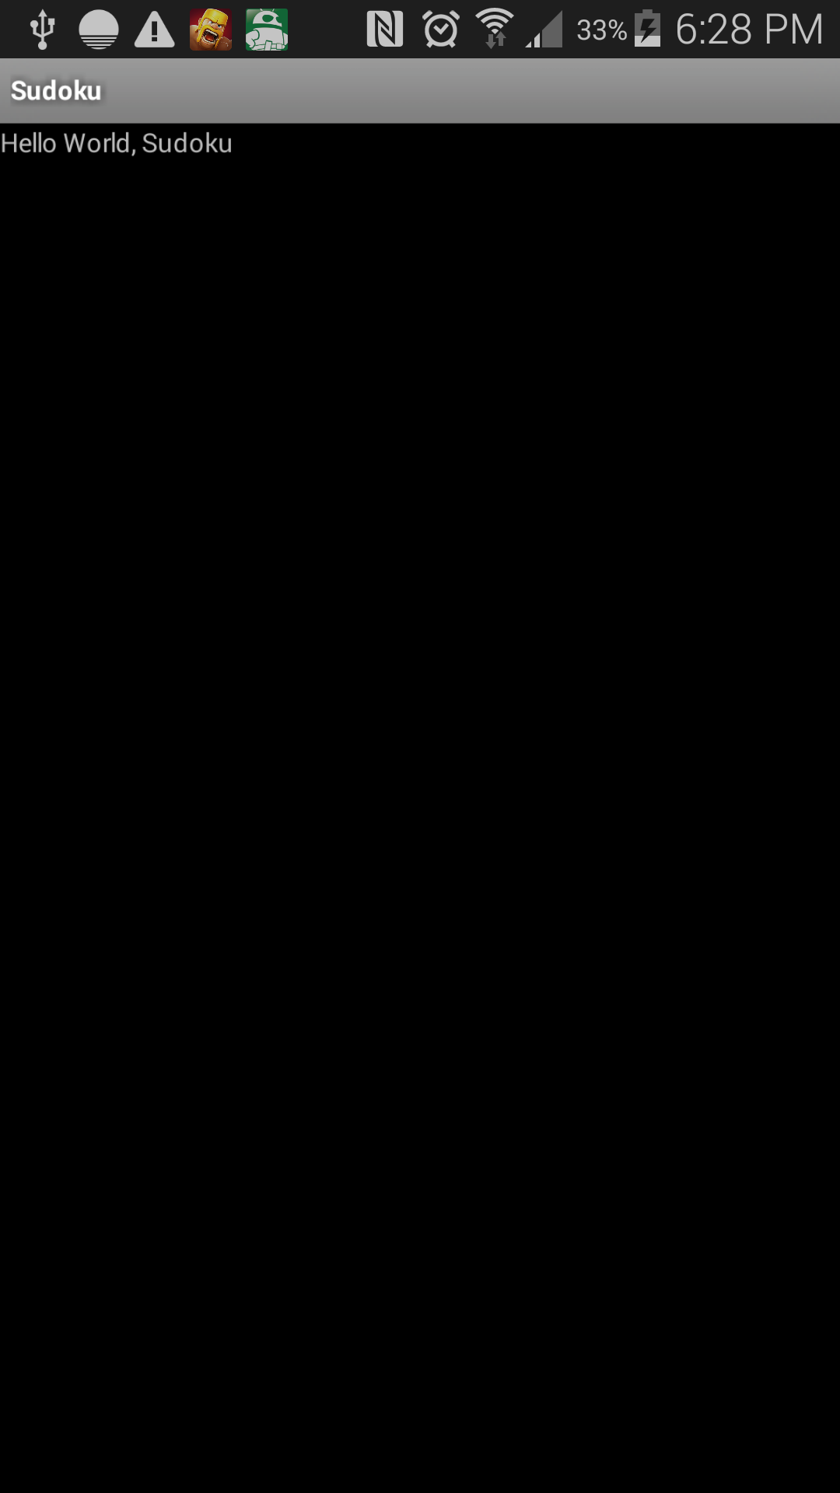

The screenshot above represents Sudoku Version 0. Sudoku Version 0 contains text in the top left that says “Hello World, Sudoku”. The app contains only one Activity, shown above.

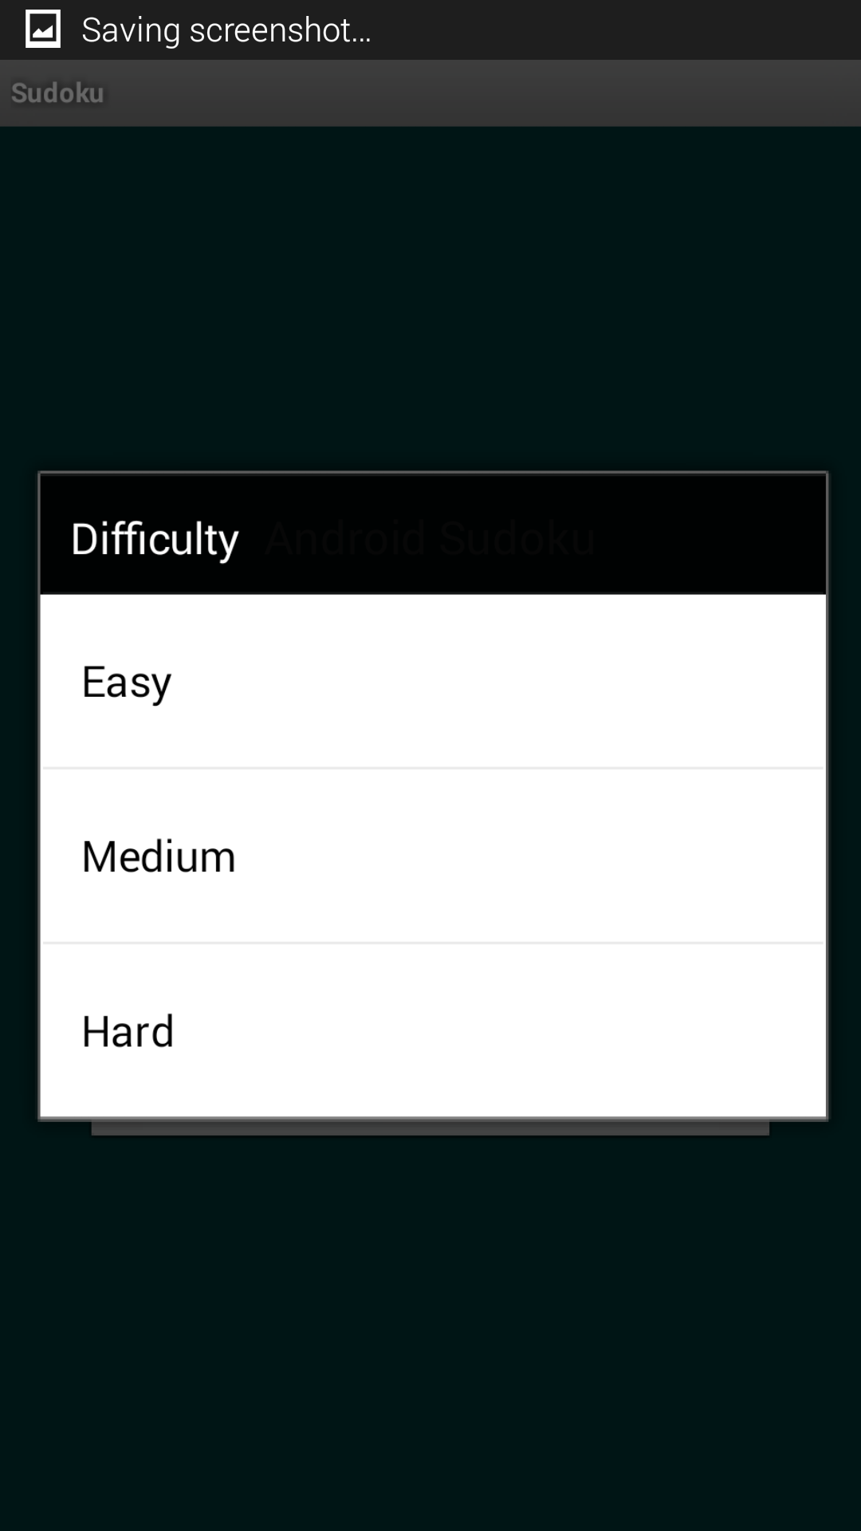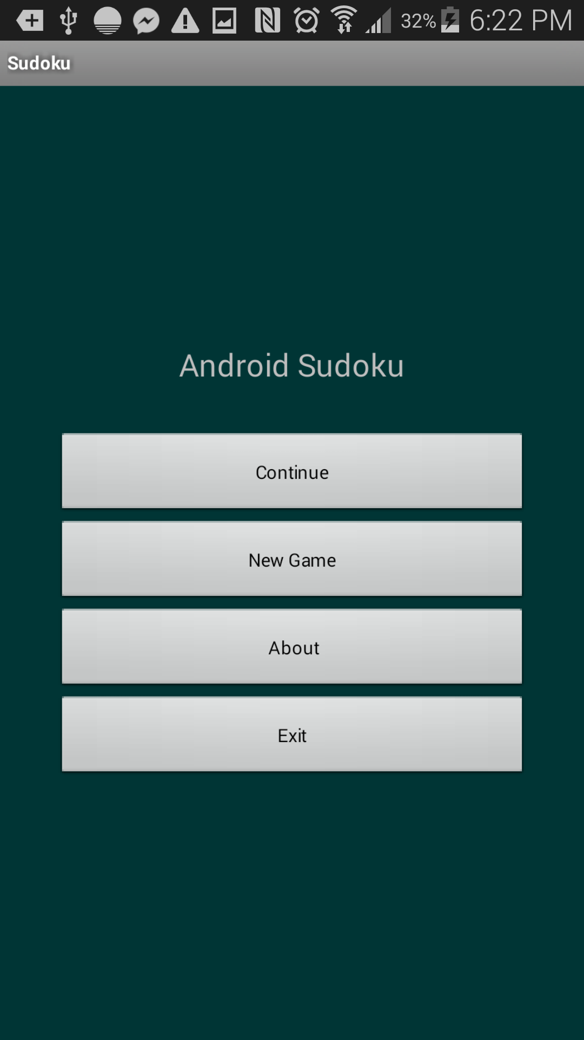

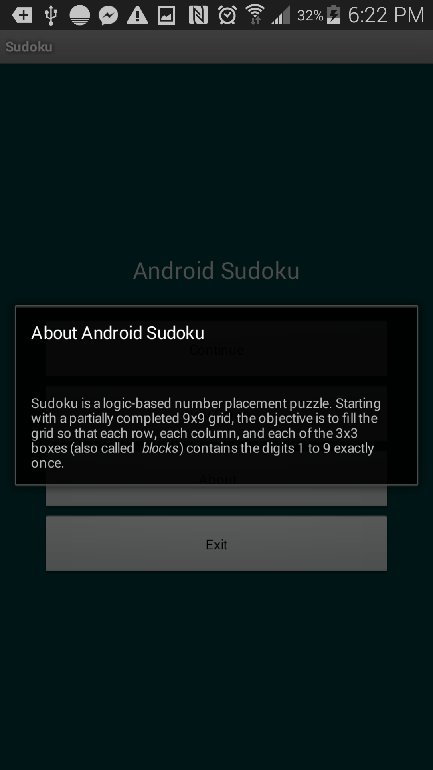

As shown by the screenshots on the page, Sudoku Version 1 is more complex. The app contains three activities, instead of one. The app also contains four buttons on the screen. Note that the continue button does not work, clicking on the difficulty buttons does not work either, but the about and new game button work.

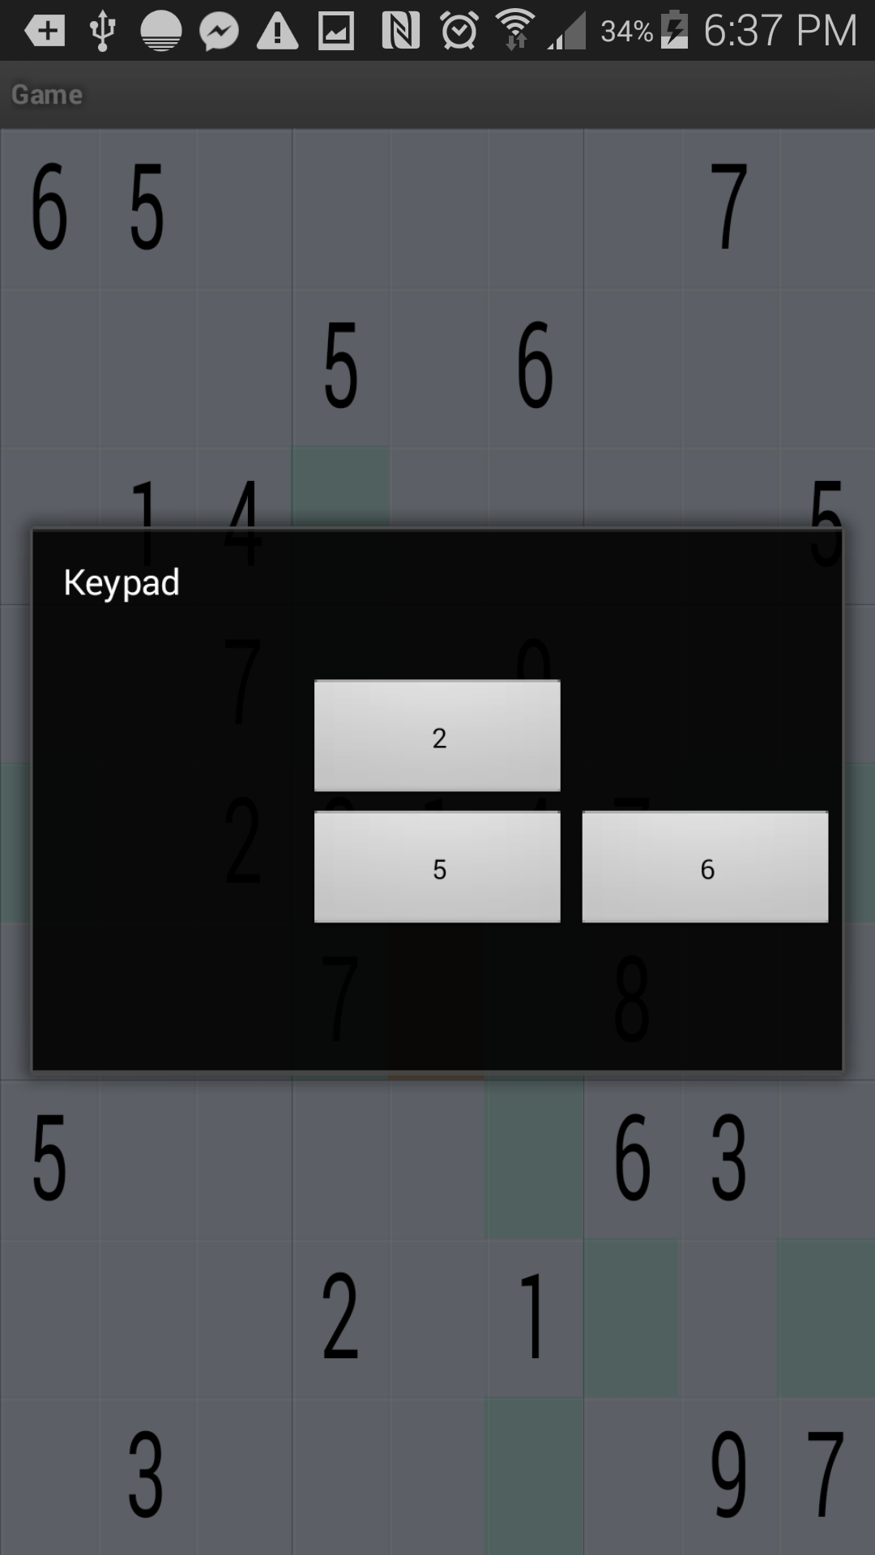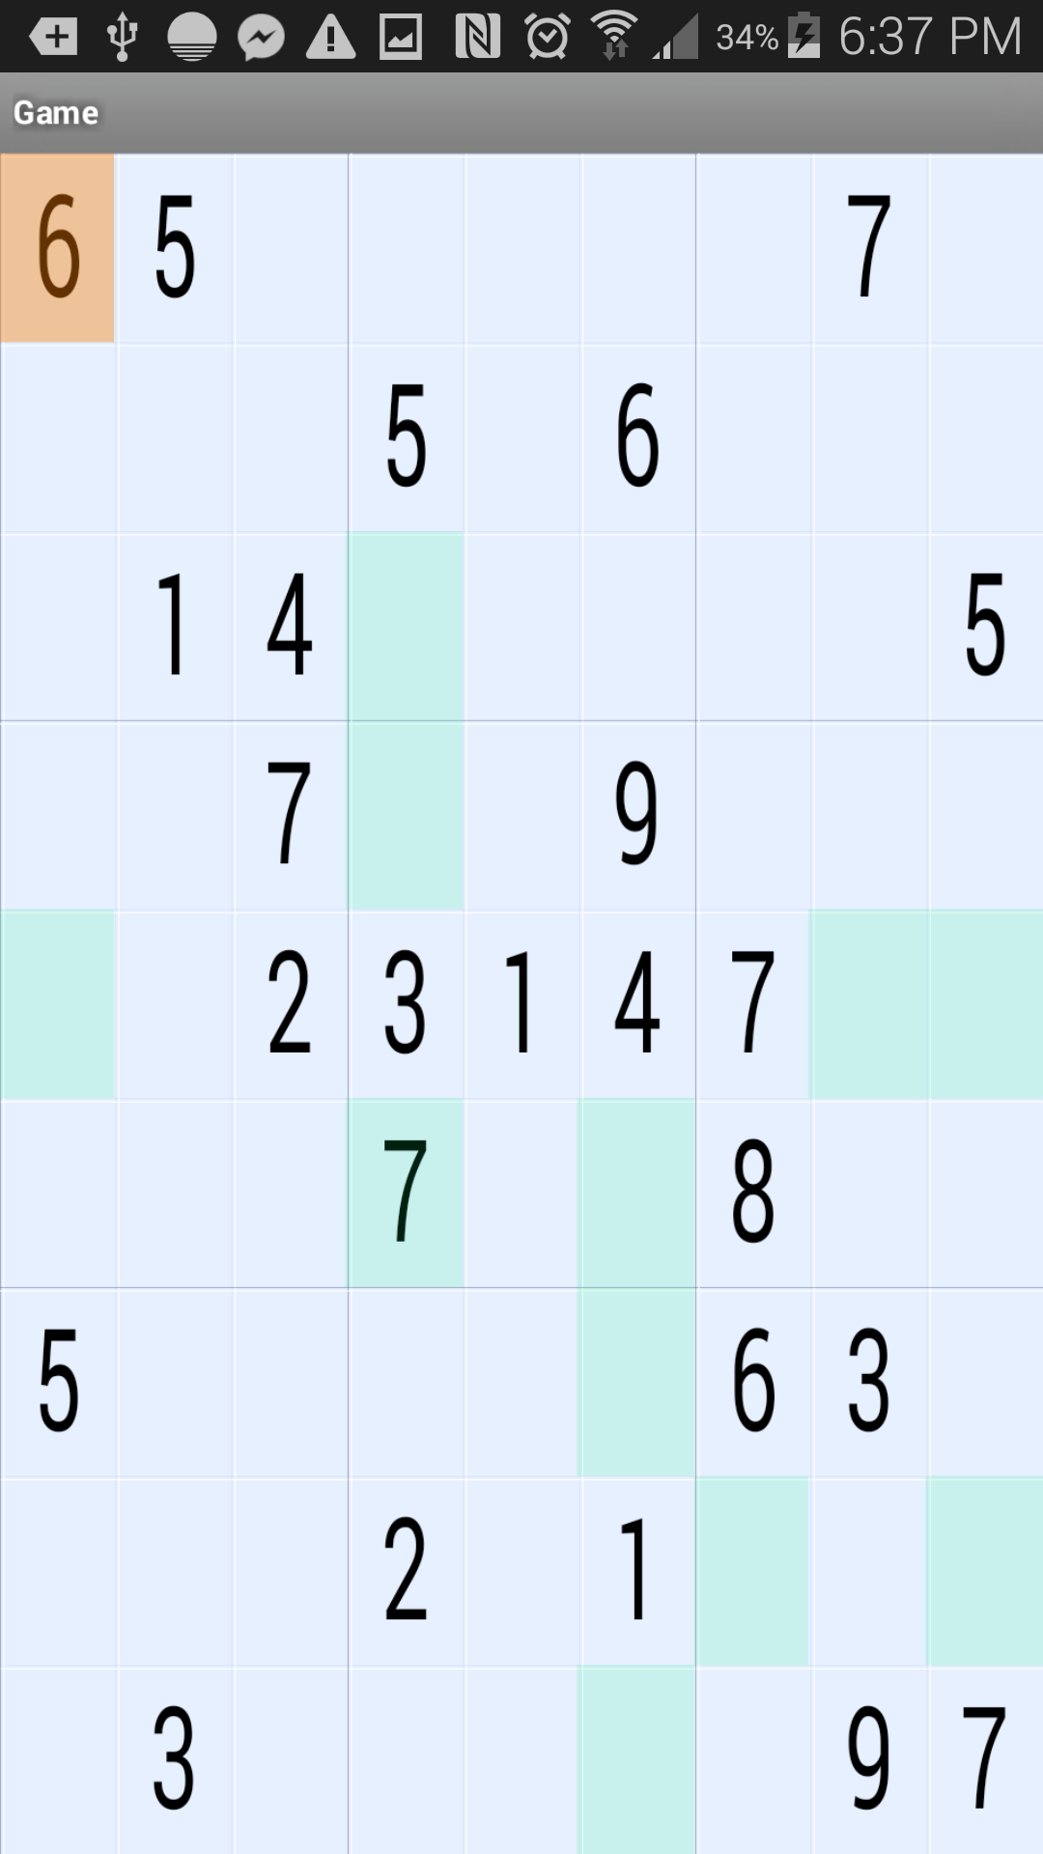

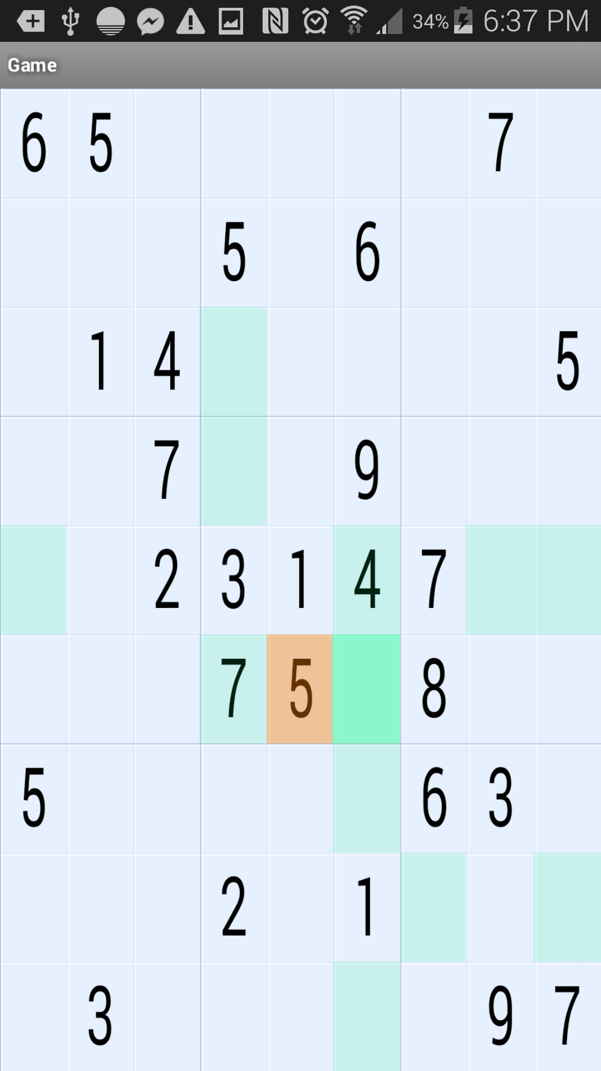

The difference between Sudoku Version 2 and Sudoku Version 3 is there is one more Activity in Sudoku Version 3. This activity provides the game with music. Other than that, there are no other noticeable differences between Sudoku Version 2 and Sudoku Version 3. Unfortunately, I cannot screenshot the music.

The screenshots above from Sudoku Version 2. In this version of the app, when clicking on a difficulty, a Sudoku board is opened on the screen. When tapping in an empty space a window appears on the screen. This windows allows the user to enter a value into the selected square. After choosing a value, the windows disappears and the empty square is replaced by a square with a value. There are six activities in Sudoku Version 2 instead of three activities in Sudoku Version 1.

The difference between Sudoku Version 4 and Sudoku Version 3 is that Sudoku Version 4 contains an Option activity. This activity allows the user to change the game options. The user can turn on music, turn off music, turn on hints, and turn off hints.

I made some minor adjustments to the game, with the artist’s suggestions. For example, I changed some of the string values. On the title screen, I changed “Sudoku Android” to “Android for Sudoku”. I also changed the colors of the app, because the original colors were less aesthetically appealing. The new colors are brighter, and the new colors I chose make the app more colorful. For example, the background on the starting screen was dark green color, which I changed to a better, lighter color. I also changed the main screen’s text color to white, so that it wouldn’t blend into the background. I also changed the music that played, because the original music was annoying so I changed the tune to something less annoying and more pleasant.